36) Aim: To Design Non Deterministic Finite Automata using simulator to accept the string the start with a and end with b over set {a,b} and check W= abaab is accepted or not.

Diagram:

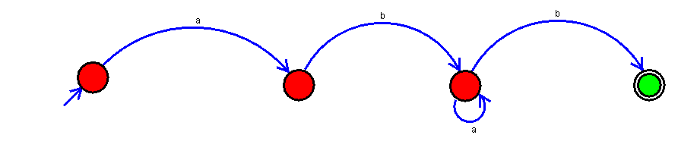

Result:

Successfully executed Non Deterministic Finite Automata using simulator to accept the string the start with a and end with b over set {a,b} and check W= abaab is accepted or not.